**Introduction to Database Systems**

**AYKN University**

**Project Schema Report**

**Team Number: 3**

Team Members

|  |  |  |
| --- | --- | --- |
| Name | Sec | ID |
| Ahmed Samy | 1 | 9210073 |
| Kareem Samy | 2 | 9210838 |
| Nancy Ayman | 2 | 9213410 |
| Yara Hisham | 2 | 9211350 |

Contact info

[ahmed.mohamed202@eng-st.cu.edu.eg](mailto:ahmed.mohamed202@eng-st.cu.edu.eg)

[karim.elsayed401@eng-st.cu.edu.eg](mailto:karim.elsayed401@eng-st.cu.edu.eg)

[Nancyayman89@gmail.com](mailto:Nancyayman89@gmail.com)

[yara.mahrous01@eng-st.cu.edu.eg](mailto:yara.mahrous01@eng-st.cu.edu.eg)

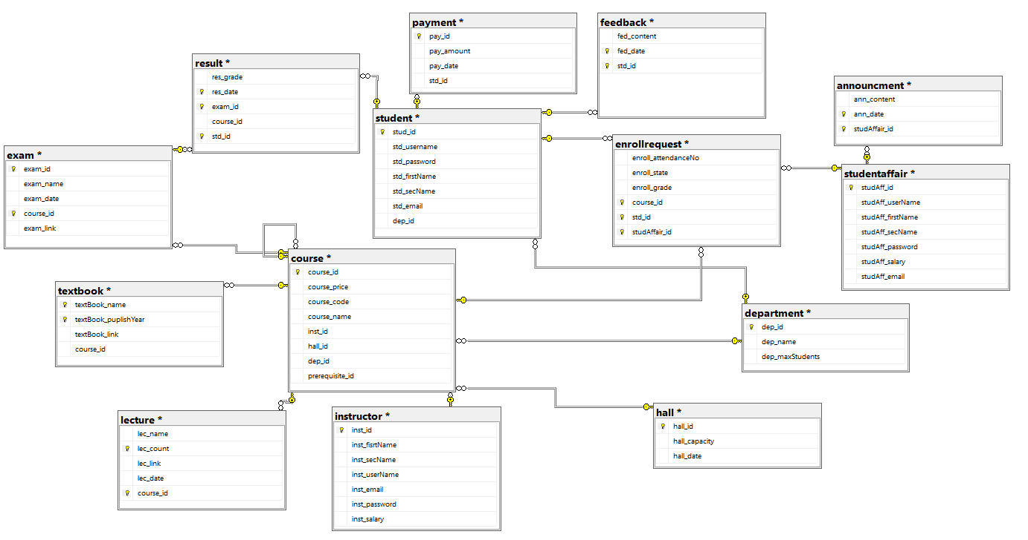**schema diagram:**